**LIKE**

**UNIVERSITY**

**(University Management System)**



**Our motto**

**Explore, Learn, Thrive**

**MODULES**

* University application form
* Student Creation
* Fees Payments
* Results
* Event & Events Registration
* Insights (Reports & Dashbords)

**Profiles:**

1. Management
2. Professor
3. CR

**Objects:**

1. Student

* Student name (Text)
  + First Name
  + Last Name
* Father/Guardian name (Text) (Company)
* Date of Birth (Date)
* Gender (Male, Female, Others)
* Department (Lookup)
* Email (Email)
* Phone (Phone)
* Address (Street, city, PIN code, state, Country)
* Student ID (auto)
* Year of join (Formula Field –TEXT(YEAR (TODAY ())))
* 10th board
* 10th score
* 12th board
* 12th score
* Sem 1 total subjects – Roll-up summary
* Sem 1 passed subjects – Roll-up summary
* Sem1 Actual CGPA total-Roll-up summary
* Sem 1 CGPA-formula
* Similarly above for sem2 – sem8

1. Professor

* Professor ID (auto)
* Professor Name
* Department (Lookup)
* Subject (lookup)
* Experience (Number)
* Email (Email)
* Phone (Phone)
* HOD(Checkbox) – Check if he is HOD

1. Department

* Department ID(Auto)
* Department Name(text)
* Fees Per Semester (Currency)

1. Marks
   * + - Student id(master detail)
       - Department (Formula Field)
       - Semester(Picklist)
       - Subject ID(Lookup)
       - Subject Name(Formula)
       - Subject Grade Points(Formula Field)
       - Subject Grade(Formula)---will be created later
       - Subject Marks(Number(3,1))
2. Fee payments
   * + Payment ID(Auto Num)
     + Student ID(Master-Detail)
     + -Student Name(Formula)
     + -Department(Auto-populates--formula)
     + Semester(Picklist)
     + -Fees Amount(Autopopulate--formula)
     + Paid(checkbox)
     + Mode Of Payment (Picklist)
3. Lead

* Student name
* Father/Guardian name (Company)
* Date of Birth
* Gender(Male, Female, Others)
* Department(picklist)
  + CSE
  + ECE
  + EEE
  + MECH
  + CIVIL
* Email (Email)
* Phone (Phone)
* Address (Street, city, PIN code, state, Country)
* 10th board name(global picklist)
* State Board
* CBSE
* ICSE
* 10th score
* 12th board name(global picklist)
* 12th score
* Admission Fees paid – checkbox
* Application Status (Picklist)
  + - * + New
        + Pending
        + Approved
        + Rejected

**7)Subject**

* Subject Code
* Subject Name
* Department ID(Lookup)
* SEM(Picklist)

**8)Event**

* Contact_Organizer__c
* Event_Date_Time__c
* Event_Details__c
* Event_Status__c
* Event_Venue__c
* Name
* Organizer__c
* Registration_End_Date__c
* Registration_Start_Date__c
* Registration_Status__c
* specify_venue_if_others__c

9)Event Registration

* Event_Name__c
* Name
* Role_in_event__c – (Picklist)
* Organizer
* Volunteer
* Participant
* Guest Participant
* Student_ID__c

**\*Note** - Most of above fields have their respective Validations which are not documented here. Please choose according to project requirements.

**Duplicate rule:** for lead object

Using Email &phone

Action when creating- block

Action when editing – block

**Formula Fields:**

1. **Student – Year of Join –** YEAR(TODAY())
2. **Student – Age -** (TRUNC( ( TODAY() - Date_of_Birth__c ) , 0 ))/365
3. **Mark – CGPA –**

IF( ISBLANK( Subject_Marks__c ), VALUE('') ,

IF( Subject_Marks__c > 90 && Subject_Marks__c <= 100, 10,

IF(Subject_Marks__c > 80 && Subject_Marks__c <= 90, 9 ,

IF(Subject_Marks__c > 70 && Subject_Marks__c <= 80, 8 ,

IF(Subject_Marks__c > 60 && Subject_Marks__c <= 70, 7 ,

IF(Subject_Marks__c > 55 && Subject_Marks__c <= 60, 6 ,

IF(Subject_Marks__c >= 50 && Subject_Marks__c <= 55, 5 ,

IF(Subject_Marks__c >=40 && Subject_Marks__c <50, 4 , 0))))))))

**4)Mark – Grade –**

IF(ISBLANK(Subject_CGPA__c), 'N/A', CASE( Subject_CGPA__c , 10, 'O', 9, 'A+',8,'A',7,'B+',6,'B',5,'C',4,'P',0,'F', 'N/A'))

5)**Student – CGPA** –

IF( Sem_1_total_subjects__c = Sem_1_Passed_Subjects__c , Semester_1_Actual_CGPA__c / Sem_1_Passed_Subjects__c , 0)

**EMAIL ALERTS :**

**1)Accepting Mail:**



On approval of the application the above email is sent.

**2)Rejecting Mail**



On rejection of the application, this mail is sent.

**FLOWS:**

**1)Application Auto Approval Process:**

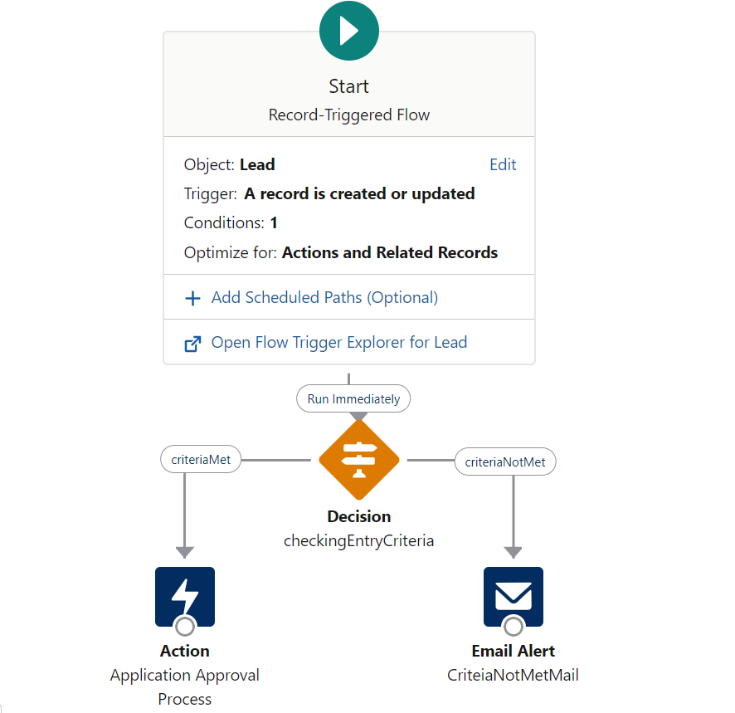

This is an auto approval process that sends application for management approval, if management approves application, then a mail alert is sent to pay application fees else an rejection mail is sent.

**2) Creating an Student from Lead automatically on admission fees payment**

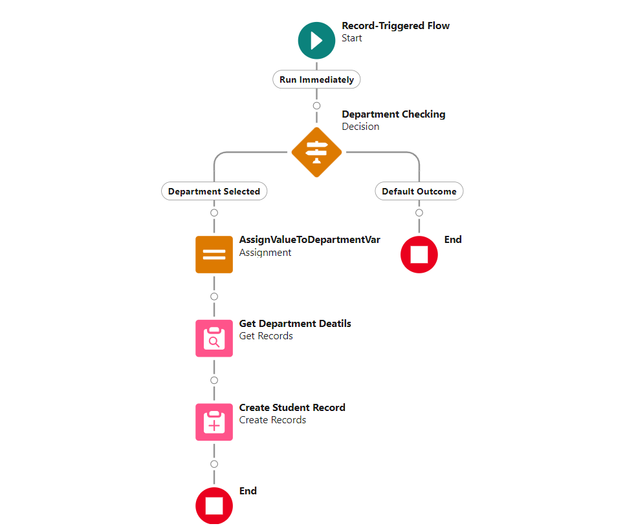

On admission fees payment marked as paid, the Application(Lead) is converted to student automatically.

**3) Fees Payment Screen Flow**

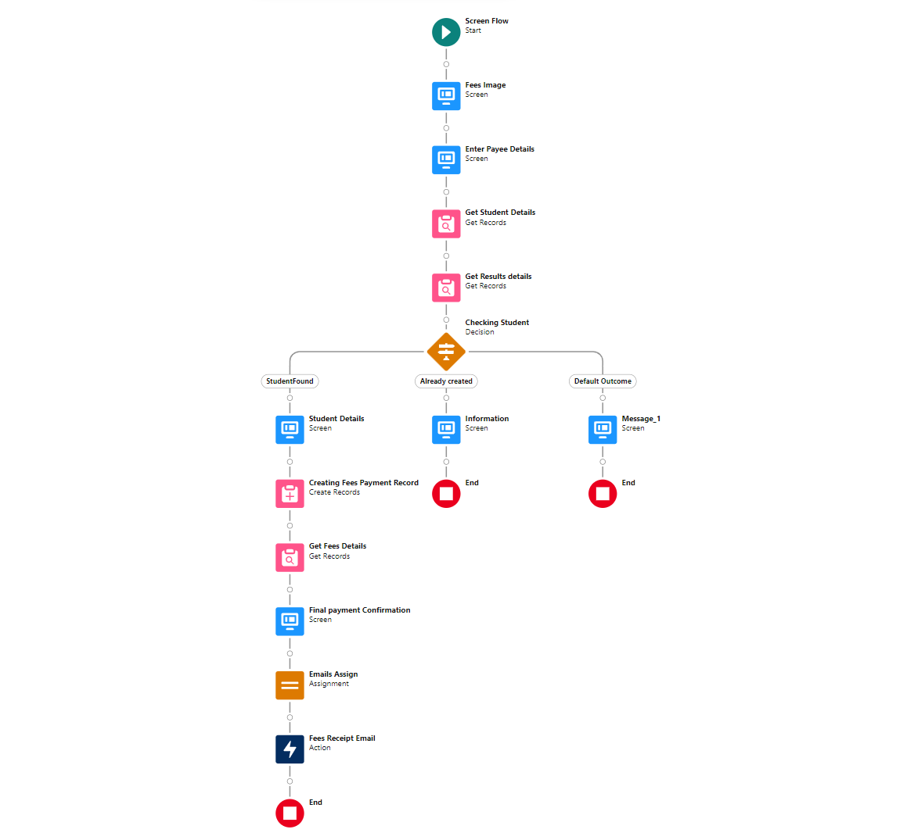

This screen flow is used by management to create a record on fees payment of a student and sent an email to student.

Working this screenflow

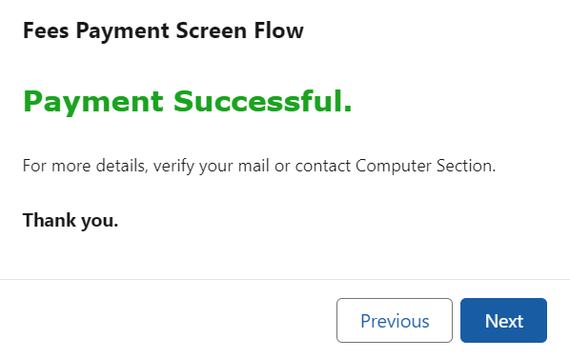

1. **Auto-creating results based on fees payment for semester**

This is used for automatically creating results for each subject of semester for which student has paid the fees. For example, If student pays fee for semester-1, the all the subjects of the respective semester is created & based on student department.

1. **Check Results Screen Flow**

This is used to check results of student.

Working of above screen flow

**Approval Process Used in Flow**

This is an approval process that is used for application approval.

**C.R.U.D ACCESS ON PROFILE**

Management:

|  |  |  |  |  |
| --- | --- | --- | --- | --- |
|  | **Read** | **Create** | **Edit** | **Delete** |
| **Departments** | **þ** | **þ** | **þ** | **þ** |
| **Fees Payments** | **þ** | **þ** | **þ** | **þ** |
| **Professors** | **þ** | **þ** | **þ** | **þ** |
| **Result** | **þ** | **þ** | **þ** | **þ** |
| **Student** | **þ** | **þ** | **þ** | **þ** |
| **Subjects** | **þ** | **þ** | **þ** | **þ** |
| **Leads** | **þ** | **þ** | **þ** | **þ** |
| **Events** | **þ** | **þ** | **þ** | **þ** |
| **Event Registration** | **þ** | **þ** | **þ** | **þ** |

Professor:

|  |  |  |  |  |
| --- | --- | --- | --- | --- |
|  | **Read** | **Create** | **Edit** | **Delete** |
| **Departments** | **þ** | **ý** | **ý** | **ý** |
| **Fees Payments** | ý | **ý** | **ý** | **ý** |
| **Professors** | **þ** | **ý** | **ý** | **ý** |
| **Result** | **þ** | **ý** | **þ** | **ý** |
| **Student** | **þ** | **ý** | **ý** | **ý** |
| **Subjects** | **þ** | **ý** | **ý** | **ý** |
| **Event** | **þ** | **ý** | **þ** | **ý** |
| **Event Registration** | **þ** | **þ** | **þ** | **ý** |

CR:

|  |  |  |  |  |
| --- | --- | --- | --- | --- |
|  | **Read** | **Create** | **Edit** | **Delete** |
| **Departments** | **ý** | **ý** | **ý** | **ý** |
| **Fees Payments** | **ý** | **ý** | **ý** | **ý** |
| **Professors** | **ý** | **ý** | **ý** | **ý** |
| **Result** | **ý** | **ý** | **ý** | **ý** |
| **Student** | **ý** | **ý** | **ý** | **ý** |
| **Subjects** | **ý** | **ý** | **ý** | **ý** |
| **Leads** | **ý** | **ý** | **ý** | **ý** |
| **Events** | **þ** | **ý** | **ý** | **ý** |
| **Event Registration** | **þ** | **þ** | **ý** | **ý** |

Student:

Student is a guest user he can check his/her results and payments from college website (no login needed). (Built using Experience Builder & LWC)

WEB-TO-LEAD FORM AS APPLICATION FROM ALONG WITH VS CODE VALIDATIONS:

<!DOCTYPE html>

<html lang="en">

<head>

<meta charset="UTF-8">

<!-- <meta name="viewport" content="width=, initial-scale=1.0"> -->

<title>Application | Like University</title>

<link rel="icon" type="image/x-icon" href=".\\logo_no_bg_favicon_32.png">

<link rel="stylesheet" href="https://cdn.jsdelivr.net/npm/bootstrap@4.6.2/dist/css/bootstrap.min.css"

integrity="sha384-xOolHFLEh07PJGoPkLv1IbcEPTNtaed2xpHsD9ESMhqIYd0nLMwNLD69Npy4HI+N" crossorigin="anonymous">

<script src="https://cdn.jsdelivr.net/npm/bootstrap@4.6.2/dist/js/bootstrap.bundle.min.js"

integrity="sha384-Fy6S3B9q64WdZWQUiU+q4/2Lc9npb8tCaSX9FK7E8HnRr0Jz8D6OP9dO5Vg3Q9ct"

crossorigin="anonymous"></script>

<script src="https://cdn.jsdelivr.net/npm/jquery@3.5.1/dist/jquery.slim.min.js"

integrity="sha384-DfXdz2htPH0lsSSs5nCTpuj/zy4C+OGpamoFVy38MVBnE+IbbVYUew+OrCXaRkfj"

crossorigin="anonymous"></script>

<script src="https://cdn.jsdelivr.net/npm/popper.js@1.16.1/dist/umd/popper.min.js"

integrity="sha384-9/reFTGAW83EW2RDu2S0VKaIzap3H66lZH81PoYlFhbGU+6BZp6G7niu735Sk7lN"

crossorigin="anonymous"></script>

<script src="https://cdn.jsdelivr.net/npm/bootstrap@4.6.2/dist/js/bootstrap.min.js"

integrity="sha384-+sLIOodYLS7CIrQpBjl+C7nPvqq+FbNUBDunl/OZv93DB7Ln/533i8e/mZXLi/P+"

crossorigin="anonymous"></script>

<link href='https://cdnjs.cloudflare.com/ajax/libs/bootstrap-datepicker/1.9.0/css/bootstrap-datepicker.min.css'

rel='stylesheet' type='text/css'>

<script src='https://cdnjs.cloudflare.com/ajax/libs/bootstrap-datepicker/1.9.0/js/bootstrap-datepicker.min.js'

type='text/javascript'></script>

<style>

#header {

height: 100px;

width: auto;

background-image: url(".\\Untitled design.png");

background-position: center;

background-repeat: no-repeat;

background-size: cover;

}

.marquee {

height: 50px;

overflow: hidden;

position: relative;

background: #fefefe;

color: red;

font-weight: 700;

font-size: small;

border: 1px solid #4a4a4a;

}

.marquee p {

position: absolute;

width: 100%;

height: 100%;

margin: 0;

line-height: 50px;

text-align: center;

-moz-transform: translateX(100%);

-webkit-transform: translateX(100%);

transform: translateX(100%);

-moz-animation: scroll-left 2s linear infinite;

-webkit-animation: scroll-left 2s linear infinite;

animation: scroll-left 20s linear infinite;

}

@-moz-keyframes scroll-left {

0% {

-moz-transform: translateX(100%);

}

100% {

-moz-transform: translateX(-100%);

}

}

@-webkit-keyframes scroll-left {

0% {

-webkit-transform: translateX(100%);

}

100% {

-webkit-transform: translateX(-100%);

}

}

@keyframes scroll-left {

0% {

-moz-transform: translateX(100%);

-webkit-transform: translateX(100%);

transform: translateX(100%);

}

100% {

-moz-transform: translateX(-100%);

-webkit-transform: translateX(-100%);

transform: translateX(-100%);

}

}

.form-group.required .control-label:after {

color: #d00;

content: "*";

position: absolute;

margin-left: 3px;

top: 4px;

}

label {

font-weight: 700;

font-size: 14px;

color: black;

}

#formbody {

height: 1100px;

width: auto;

background-image: url(".\\vadim-sherbakov-d6ebY-faOO0-unsplash.jpg");

background-position: center;

background-size: cover;

}

#formbody>#cont {

width: 50%;

height: auto;

background-color: rgb(241, 241, 241);

opacity: 0.9;

}

#footer {

height: 50px;

width: auto;

background-color: black;

color: white;

font-size: 14px;

}

input[type="text"],

textarea {

background-color: white;

opacity: 1;

}

.error {

font-size: 16px;

margin: 0;

padding: 0;

color: red;

}

.btn-group-vertical a {

border: 2px solid white;

background-color: transparent;

color: white;

padding: 5px;

margin: 3px;

width: 180px;

border-radius: 5px;

transition-duration: 0.4s;

}

.btn-group-vertical a:hover {

background-color: white;

color: black;

}

.datepicker {

padding: 20px;

border-radius: 5px;

background-color: #f8f9fa;

color: #495057;

box-shadow: 0 0.5rem 1rem rgba(0, 0, 0, 0.15);

}

.datepicker table tr td,

.datepicker table tr th {

border-radius: 20px;

height: 32px;

width: 32px;

font-size: 0.875rem;

}

.datepicker table tr td.active,

.datepicker table tr td.active:hover,

.datepicker table tr td.active.disabled,

.datepicker table tr td.active.disabled:hover {

background-color: #007bff;

color: #fff;

}

.datepicker .datepicker-switch,

.datepicker .prev,

.datepicker .next {

font-size: 1.25rem;

}

.datepicker .datepicker-switch:hover,

.datepicker .prev:hover,

.datepicker .next:hover {

background-color: #e9ecef;

}

.datepicker .datepicker-switch {

width: 220px;

}

</style>

<script>

$(document).ready(function () {

$('#00NGA00000UJCNw').datepicker({

format: 'dd/mm/yyyy',

changeMonth: true,

changeYear: true,

autoclose: true,

todayHighlight: true,

clearBtn: true

});

});

function formSubmit() {

var dateOfBirth = document.getElementById("00NGA00000UJCNw").value.split("/");

var modDOB = `${dateOfBirth[1]}/${dateOfBirth[0]}/${dateOfBirth[2]}`

var tenScore = document.getElementById("00NGA00000UJCOV").value;

var interScore = document.getElementById("00NGA00000UJCOk").value;

var declarationCheck = document.getElementById("gridCheck").checked;

var dobDate = new Date(modDOB).getTime();

var nowDate = new Date().getTime();

var time_diff = nowDate - dobDate;

var days_diff = time_diff / (1000 * 24 * 60 * 60);

//console.log(days_diff < (17 * 365));

if (days_diff < (17 * 365)) {

document.getElementById("ageError").innerHTML = "<small>Your age should be above 17.</small>";

document.getElementById("00NGA00000UJCNw").focus();

return false;

}

if (parseFloat(tenScore) < 7 || parseFloat(tenScore > 10)) {

document.getElementById("tenError").innerHTML = "<small>10th Score should be between 7 and 10.</small>";

document.getElementById("00NGA00000UJCOV").focus();

return false;

}

if (parseFloat(interScore) < 7 || parseFloat(interScore > 10)) {

document.getElementById("interError").innerHTML = "<small>12th Score should be between 7 and 10.</small>";

document.getElementById("00NGA00000UJCOk").focus();

return false;

}

if (declarationCheck == false) {

document.getElementById("checkError").innerHTML = "<small>Check this declation.</small>";

document.getElementById("gridCheck").focus();

document.getElementById("checkError").animate([{ opacity: 0 }, { opacity: 1 }], {

duration: 200, // milliseconds

iterations: 5, // repeat indefinitely

});

return false;

}

}

</script>

</head>

<body>

<div class="container-fluid">

<div id="header" class="d-flex justify-content-end align-items-center">

<div class="btn-group-vertical mr-3" role="group" aria-label="Basic example">

<a class="btn btn-primary" href="https://sunrichglobal-dev-ed.develop.my.site.com/management"

role="button">Management Login</a>

<a class="btn btn-primary" href="https://sunrichglobal-dev-ed.develop.my.site.com/professors"

role="button">Professor Login</a>

</div>

</div>

<div class="marquee my-1">

<p>Embark on your journey of knowledge, our gates are wide open. Seize the moment, and submit your

application today.</p>

</div>

<div id="formbody" class="d-flex justify-content-center align-items-center">

<div id="cont" class="p-3 rounded font-weight-normal">

<div>

<p class="h2 text-center">APPLICATION FORM</p>

</div>

<div class="info p-1">

<p><span style="color:#d00;font-weight: 600;">*</span> = requied</p>

</div>

<form action=" "

method="POST" onsubmit="return formSubmit();" autocomplete="off">

<input type=hidden name="oid" value="00DGA000008YS98">

<input type=hidden name="retURL" value="https://likeuniv.github.io/likeUniversityApplicationForm/thankyou.html">

<div class="form-row">

<div class="form-group col-md-6 required">

<label for="first_name" class="control-label">First Name</label>

<input id="first_name" maxlength="40" name="first_name" size="20" type="text"

class="form-control" pattern="[a-zA-Z ]+" required />

</div>

<div class="form-group col-md-6 required">

<label for="last_name" class="control-label">Last Name</label>

<input id="last_name" maxlength="80" name="last_name" size="20" type="text"

class="form-control" pattern="[a-zA-Z ]+" required />

</div>

</div>

<div class="form-row">

<div class="form-group col-md-6 required">

<label for="company" class="control-label">Father/Guardian name</label>

<input id="company" maxlength="40" name="company" size="20" type="text" class="form-control"

pattern="[a-zA-Z ]+" />

</div>

<div class="form-group col-md-6 required">

<label class="control-label">Gender</label>

<select id="00NGA00000UJInK" name="00NGA00000UJInK" title="Gender" class="form-control"

required>

<option value="">--None--</option>

<option value="Male">Male</option>

<option value="Female">Female</option>

<option value="Others">Others</option>

</select>

</div>

</div>

<div class="form-row">

<div class="form-group col-md-6 required">

<label class="control-label">Date of Birth</label>

<span class="dateInput dateOnlyInput"><input id="00NGA00000UJCNw" name="00NGA00000UJCNw"

size="12" type="text" class="form-control" placeholder="dd/mm/yyyy"

required /></span>

<div id="ageError" class="error">

</div>

</div>

<div class="form-group col-md-6 required">

<label class="control-label">Department</label>

<select id="00NGA00000UJCO1" name="00NGA00000UJCO1" title="Department" class="form-control">

<option value="">--None--</option>

<option value="CSE">CSE</option>

<option value="ECE">ECE</option>

<option value="EEE">EEE</option>

<option value="MECH">MECH</option>

<option value="CIVIL">CIVIL</option>

</select>

</div>

</div>

<div class="form-row">

<div class="form-group col-md-6 required">

<label for="mobile" class="control-label">Mobile</label>

<input id="mobile" maxlength="40" name="mobile" size="20" type="text" class="form-control"

pattern="[6-9]{1}[0-9]{9}" placeholder="0000000000" required />

</div>

<div class="form-group col-md-6 required">

<label for="email" class="control-label">Email</label>

<input id="email" maxlength="80" name="email" size="20" type="text" class="form-control"

pattern="[a-z0-9._%+\-]+@[a-z0-9.\-]+\.[a-z]{2,}$" placeholder="joe@testmail.com"

required />

</div>

</div>

<div class="form-row">

<div class="form-group col-md-6 required">

<label class="control-label">10th Board Name</label>

<select id="00NGA00000UJCOQ" name="00NGA00000UJCOQ" title="10th Board Name"

class="form-control" required>

<option value="">--None--</option>

<option value="State Board">State Board</option>

<option value="CBSE">CBSE</option>

<option value="ICSE">ICSE</option>

</select>

</div>

<div class="form-group col-md-6 required">

<label class="control-label">10th Score</label>

<input id="00NGA00000UJCOV" name="00NGA00000UJCOV" size="20" type="text"

class="form-control" placeholder="10.00"

pattern="^(10(\.0{1,2})?|[0-9](\.[0-9]{1,2})?)$" required />

<div id="tenError" class="error">

</div>

</div>

</div>

<div class="form-row">

<div class="form-group col-md-6 required">

<label class="control-label">12th Board Name</label>

<select id="00NGA00000UJCOf" name="00NGA00000UJCOf" title="12th Board Name"

class="form-control" required>

<option value="">--None--</option>

<option value="State Board">State Board</option>

<option value="CBSE">CBSE</option>

<option value="ICSE">ICSE</option>

</select>

</div>

<div class="form-group col-md-6 required">

<label class="control-label">12th Score</label>

<input id="00NGA00000UJCOk" name="00NGA00000UJCOk" size="20" type="text"

class="form-control" placeholder="10.00"

pattern="^(10(\.0{1,2})?|[0-9](\.[0-9]{1,2})?)$" required />

<div id="interError" class="error">

</div>

</div>

</div>

<div class="form-group required">

<label>Student Address</label>

<textarea id="00NGA00000UJN7a" name="00NGA00000UJN7a" rows="4" type="text"

class="form-control"></textarea><br>

</div>

<div class="form-group">

<div class="form-check">

<input class="form-check-input" type="checkbox" id="gridCheck">

<label class="form-check-label" for="gridCheck">

<small>I hereby declare that the information provided in this application is true and

correct to the best of my knowledge and belief. I understand that any false or

misleading information may lead to the rejection of my application or cancellation

of my admission.

</small>

</label>

<div id="checkError" class="error">

</div>

</div>

</div>

<input type="submit" name="submit" class="btn btn-success">

</form>

</div>

</div>

<div id="footer" class="mt-1">

<p class="copyright ml-2">&copy; 2024 Like University. All rights reserved.</p>

</div>

</body>

</html>

SALESFORCE DEVELOPMENT

1)Trigger to create student from lead on admission fees payment.

LeadToStudentCreate.aptx:

trigger LeadToStudentCreate on Lead (after insert,after update) {

if(Trigger.isAfter && (Trigger.isInsert || Trigger.isUpdate)){

LeadToStudentHandler.createStudent(Trigger.new);

}

}

LeadToStudentHandler.apxc:

public class LeadToStudentHandler {

public static void createStudent(List<Lead> apps) {

Set<String> leadDepartments = new Set<String>();

for (Lead app : apps) {

if (app.Admission_Fee_Paid__c) {

leadDepartments.add(app.Department__c);

}

}

Map<String, Id> departmentMap = new Map<String, Id>();

for (Department__c dept : [SELECT Id, Name FROM Department__c WHERE Name IN :leadDepartments]) {

departmentMap.put(dept.Name, dept.Id);

}

List<Student__c> studentList = new List<Student__c>();

for (Lead ld : apps) {

if (ld.Admission_Fee_Paid__c) {

Id deptId = departmentMap.get(ld.Department__c);

if (deptId != null) {

Student__c s = new Student__c();

s.First_Name__c = ld.FirstName;

s.Last_Name__c = ld.LastName;

s.Father_Guardian_Name__c = ld.Company;

s.Phone__c = ld.MobilePhone;

s.Email__c = ld.Email;

s.Student_Address__c = ld.Student_Address__c;

s.Gender__c = ld.Gender__c;

s.X10th_Board_Name__c = ld.X10th_Board_Name__c;

s.X10th_Score__c = ld.X10th_Score__c;

s.X12th_Board_Name__c = ld.X12th_Board_Name__c;

s.X12th_Score__c = ld.X12th_Score__c;

s.Department_ID__c = deptId;

s.Date_of_Birth__c = ld.Date_of_Birth__c;

studentList.add(s);

} else {

System.debug('No matching department found for Lead Department: ' + ld.Department__c);

}

}

}

if (!studentList.isEmpty()) {

try {

insert studentList;

} catch (DmlException e) {

System.debug('Error inserting students: ' + e.getMessage());

}

}

}

}

-------------------------------------------------------------------------------------------------------

2) Trigger to create all subjects when fees is paid for particular semester.

FeesPaidToResult.apxt:

trigger FeesPaidToResult on Fees_Payment__c (after insert,after update) {

if(Trigger.isAfter && (Trigger.isUpdate || Trigger.isInsert)){

FeesPaidToSemHandler.createResults(Trigger.new);

}

}

FeesPaidToResultHandler.apxc:

public class public class FeesPaidToResultHandler {

public static void createResults(List<Fees_Payment__c> feesList){

Set<Id> studentIds = new Set<Id>();

for (Fees_Payment__c fees : feesList) {

if(fees.Paid__c == true){

studentIds.add(fees.Student_ID__c);

}

}

Map<Id, Student__c> studentMap = new Map<Id, Student__c>([SELECT Id, Department_ID__c FROM Student__c WHERE Id IN :studentIds]);

Map<Id, Set<String>> deptSemesterMap = new Map<Id, Set<String>>();

for (Fees_Payment__c fees : feesList) {

Student__c student = studentMap.get(fees.Student_ID__c);

if (student != null) {

if (!deptSemesterMap.containsKey(student.Department_ID__c)) {

deptSemesterMap.put(student.Department_ID__c, new Set<String>());

}

deptSemesterMap.get(student.Department_ID__c).add(fees.Semester__c);

}

}

List<Subject__c> subjectList = [SELECT Id, Name, Department_Id__c, Semester__c

FROM Subject__c

WHERE Department_id__c IN :deptSemesterMap.keySet()];

Map<String, List<Subject__c>> subjectMap = new Map<String, List<Subject__c>>();

for (Subject__c sub : subjectList) {

String key = sub.Department_id__c + '_' + sub.Semester__c;

if (!subjectMap.containsKey(key)) {

subjectMap.put(key, new List<Subject__c>());

}

subjectMap.get(key).add(sub);

}

List<Result__c> resList = new List<Result__c>();

for (Fees_Payment__c fees : feesList) {

Student__c student = studentMap.get(fees.Student_ID__c);

if (student != null) {

String key = student.Department_id__c + '_' + fees.Semester__c;

List<Subject__c> subjects = subjectMap.get(key);

if (subjects != null) {

for (Subject__c sub : subjects) {

Result__c res = new Result__c();

res.Student_ID__c = student.Id;

res.Semester__c = fees.Semester__c;

res.Subject_Code__c = sub.Id;

resList.add(res);

}

}

}

}

if (!resList.isEmpty()) {

try {

insert resList;

} catch (DmlException e) {

System.debug('Failed to insert results: ' + e.getMessage());

}

}

}

} {

public static void createResults(List<Fees_Payment__c> feesList){

Set<Id> studentIds = new Set<Id>();

for (Fees_Payment__c fees : feesList) {

if(fees.Paid__c == true){

studentIds.add(fees.Student_ID__c);

}

}

Map<Id, Student__c> studentMap = new Map<Id, Student__c>([SELECT Id, Department_ID__c FROM Student__c WHERE Id IN :studentIds]);

Map<Id, Set<String>> deptSemesterMap = new Map<Id, Set<String>>();

for (Fees_Payment__c fees : feesList) {

Student__c student = studentMap.get(fees.Student_ID__c);

if (student != null) {

if (!deptSemesterMap.containsKey(student.Department_ID__c)) {

deptSemesterMap.put(student.Department_ID__c, new Set<String>());

}

deptSemesterMap.get(student.Department_ID__c).add(fees.Semester__c);

}

}

List<Subject__c> subjectList = [SELECT Id, Name, Department_Id__c, Semester__c

FROM Subject__c

WHERE Department_id__c IN :deptSemesterMap.keySet()];

Map<String, List<Subject__c>> subjectMap = new Map<String, List<Subject__c>>();

for (Subject__c sub : subjectList) {

String key = sub.Department_id__c + '_' + sub.Semester__c;

if (!subjectMap.containsKey(key)) {

subjectMap.put(key, new List<Subject__c>());

}

subjectMap.get(key).add(sub);

}

List<Result__c> resList = new List<Result__c>();

for (Fees_Payment__c fees : feesList) {

Student__c student = studentMap.get(fees.Student_ID__c);

if (student != null) {

String key = student.Department_id__c + '_' + fees.Semester__c;

List<Subject__c> subjects = subjectMap.get(key);

if (subjects != null) {

for (Subject__c sub : subjects) {

Result__c res = new Result__c();

res.Student_ID__c = student.Id;

res.Semester__c = fees.Semester__c;

res.Subject_Code__c = sub.Id;

resList.add(res);

}

}

}

}

if (!resList.isEmpty()) {

try {

insert resList;

} catch (DmlException e) {

System.debug('Failed to insert results: ' + e.getMessage());

}

}

}

}

-------------------------------------------------------------------------------------------------------

3)Scheduled apex class that rejects application status in lead if admission fees not paid within mentioned timeframe.

RejectingUnacceptingApplications.apxc:

public class RejectingUnacceptingApplications implements Schedulable {

public void execute(SchedulableContext sc) {

List<Lead> rejectionList = [SELECT Id,firstname, Admission_Fee_Paid__c, Days_Left_for_Rejection__c, Application_Status__c FROM Lead WHERE Application_Status__c = 'Approved' AND Admission_Fee_Paid__c = false AND Days_Left_for_Rejection__c = 0];

for(Lead ld : rejectionList){

ld.Application_Status__c = 'Rejected';

}

try{

update rejectionList;

}catch(Exception e){

System.debug(e);

}

}

}

//Run following commands

/*

RejectingUnacceptingApplications rua = new RejectingUnacceptingApplications();

String cronExp = '0 0 0 * 5,6,7 ?';

ID jobid = System.schedule('RejectApplications', cronExp , rua);

*/

Lightning Web Components(LWC):

1)Results Check LWC component:

ApexControllerClass

public with sharing class FetchResult {

    public FetchResult() {

    }

    @AuraEnabled(cacheable=true)

    public static List<Result__c> getStudent(String studentID,String dob,String semester){

        List<String>  dateSplit = dob.split('/');

        String modifiedDate = dateSplit.get(2)+'-'+dateSplit.get(1)+'-'+dateSplit.get(0);

        Date bdate = Date.valueOf(modifiedDate);

        List<Student__c> s = [select Id,First_Name__c from student__c WHERE Name=:studentID AND date_of_birth__c=:bdate LIMIT 1];

        List<Result__c> res=[select Subject_Name__c,Department__c,Subject_CGPA__c,Subject_Grade__c, Student_ID__r.Name,Student_ID__r.First_Name__c, Student_ID__r.Last_Name__c from result__c where Student_ID__c=:s.get(0).Id AND Semester__c=:semester];

        return res;

    }

}

resultCheck.html

<template>

    <lightning-card title="RESULTS" icon-name="standard:search">

        <div class="slds-m-around_medium" style="font-family: 'Segoe UI', Tahoma, Geneva, Verdana, sans-serif;">

            <div class="slds-grid slds-gutters">

                <div class="slds-col">

                    <lightning-input label="Enter Student ID :" value={sid} onchange={sidChange} required

                        placeholder="LU-XXXXXX"></lightning-input>

                </div>

                <div class="slds-col">

                    <lightning-input label="Enter DOB :" value={dob} onchange={dobChange} required

                        placeholder="dd/mm/yyyy"></lightning-input>

                </div>

            </div>

        </div>

        <div class="slds-m-around_medium">

            <div class="slds-grid slds-gutters">

                <div class="slds-col slds-size_4-of-12"></div>

                <div class="slds-col slds-size_4-of-12">

                    <lightning-combobox label="Select semester" value={semVal} options={sems} onchange={semChange}

                        required></lightning-combobox>

                </div>

                <div class="slds-col slds-size_4-of-12"></div>

            </div>

        </div>

        <!-- <div class="slds-grid slds-gutters">

            <div class="slds-col slds-size_1-of-4">

            </div>

            <div class="slds-col slds-size_1-of-4">

                <button class="slds-button slds-button_success" onclick={getResults}>Get Results</button>

            </div>

            <div class="slds-col slds-size_1-of-4">

                <button class="slds-button slds-button_destructive" onclick={clear}>Clear</button>

            </div>

            <div class="slds-col slds-size_1-of-4">

            </div>

        </div> -->

        <div class="slds-m-top_medium">

            <div class="slds-align_absolute-center">

                <button class="slds-button slds-button_success slds-m-right_medium" onclick={getResults}>Get Results</button>

                <button class="slds-button slds-button_destructive slds-m-left_medium" onclick={clear}>Clear</button>

            </div>

        </div>

        <div>

        </div>

        <template lwc:if={disp}>

            <div class="slds-box slds-m-around_medium"

                style="font-family: 'Segoe UI', Tahoma, Geneva, Verdana, sans-serif;">

                <div class="slds-align_absolute-center slds-m-top_medium slds-m-bottom_medium">

                    <span class="slds-text-color_success ">****Records Found****</span>

                </div>

                <div>

                    <dl class="slds-list_horizontal slds-wrap">

                        <dt class="slds-item_label slds-text-color_weak slds-truncate" title="First Label">Student ID

                        </dt>

                        <dd class="slds-item_detail slds-truncate" title="Description for first label">{studentId}</dd>

                        <dt class="slds-item_label slds-text-color_weak slds-truncate" title="Second Label">Student Name

                        </dt>

                        <dd class="slds-item_detail slds-truncate" title="Description for second label">{studentName}

                        </dd>

                        <dt class="slds-item_label slds-text-color_weak slds-truncate" title="Second Label">Department

                        </dt>

                        <dd class="slds-item_detail slds-truncate" title="Description for second label">{studDept}</dd>

                        <dt class="slds-item_label slds-text-color_weak slds-truncate" title="Second Label">Semester

                        </dt>

                        <dd class="slds-item_detail slds-truncate" title="Description for second label">{semVal}</dd>

                    </dl>

                </div>

                <table>

                    <thead>

                        <tr>

                            <th>SUBJECT</th>

                            <th>CGPA</th>

                            <th>GRADE</th>

                        </tr>

                    </thead>

                    <tbody>

                        <template for:each={marksDetails} for:item="md">

                            <tr key={md.Id}>

                                <td>{md.Subject_Name__c}</td>

                                <td>{md.Subject_CGPA__c}</td>

                                <td>{md.Subject_Grade__c}</td>

                            </tr>

                        </template>

                    </tbody>

                </table>

                <div>

                    <dl class="slds-list_horizontal slds-wrap slds-m-around_small">

                        <dt class="slds-item_label slds-text-color_weak slds-truncate" title="First Label">

                            Overall CGPA</dt>

                        <dd class="slds-item_detail slds-truncate" title="Description for first label">{sumOfCg}

                        </dd>

                        <dt class="slds-item_label slds-text-color_weak slds-truncate" title="Second Label">

                            Overall Grade</dt>

                        <dd class="slds-item_detail slds-truncate" title="Description for second label">

                                {getGrade}</dd>

                    </dl>

                </div>

                <div class="slds-text-align_center slds-text-color_destructive">------Thank you------</div>

            </div>

        </template>

        <template lwc:if={errorDisp}>

            <div class="slds-box slds-m-around_medium">

                <div>

                    <div>

                        <div>

                            <p class="slds-text-color_error slds-text-align_center slds-m-around_medium">!!!!No Data

                                Found!!!!</p>

                            <p class="slds-text-color_error slds-text-align_center slds-text-heading_large">Based on

                                details you entered no data avaliable. Please provide with correct details.</p>

                        </div>

                        <div class="slds-m-around_large">

                            Note : Make sure data of birth of format "dd/mm/yyyy".

                        </div>

                    </div>

                </div>

            </div>

        </template>

        <template lwc:if={errorDetails}>

            <div class="slds-box slds-m-around_medium"

                style="font-family: 'Segoe UI', Tahoma, Geneva, Verdana, sans-serif;">

                <div class="errorMsg">

                    <div class="slds-align_absolute-center">

                        <p class="slds-text-color_error">Provide all necessary data.</p>

                    </div>

                </div>

            </div>

        </template>

    </lightning-card>

</template>

resultCheck.js

import { LightningElement, track, wire } from 'lwc';

import fetchRes from '@salesforce/apex/FetchResult.getStudent';

//import getContacts from '@salesforce/apex/ContactController.getContacts';

export default class ResultCheck extends LightningElement {

    @track sid='';

    @track dob='';

    @track semVal='';

    @track sumOfCg=0;

    @track marksDetails;

    @track getGrade;

    @track filtArray;

    @track disp = false;

    @track errorDisp = false;

    @track errorDetails = false;

    @track studentName;

    @track studentId;

    @track studDept;

    @track passGrade = 'greenSpan';

    get sems(){

        return([

            { label: 'SEMESTER-1', value: 'SEM-1' },

            { label: 'SEMESTER-2', value: 'SEM-2' },

            { label: 'SEMESTER-3', value: 'SEM-3' },

            { label: 'SEMESTER-4', value: 'SEM-4' },

            { label: 'SEMESTER-5', value: 'SEM-5' },

            { label: 'SEMESTER-6', value: 'SEM-6' },

            { label: 'SEMESTER-7', value: 'SEM-7' },

            { label: 'SEMESTER-8', value: 'SEM-8' },

        ]);

    }

    sidChange(event){

        this.sid = event.target.value;

    }

    dobChange(event){

        this.dob = event.target.value;

    }

    semChange(event){

        this.semVal = event.target.value;

    }

    getResults(){

        //alert('Start');

        if(!(this.sid===''||this.dob===''||this.semVal==='')){

            //alert(this.sid+' | '+this.dob+' | '+this.semVal);

            fetchRes({studentID : this.sid, dob: this.dob,semester : this.semVal}).then((result)=>{

                if(result.length>0){

                    this.errorDetails = false;

                    this.errorDisp=false;

                    this.disp=true;

                    //console.log(result);

                    this.marksDetails=result;

                    this.calculateTotalCGPA();

                    this.sumOfCg=(this.sumOfCg/this.marksDetails.length).toFixed(2);

                    this.gettingGrade();

                    this.studentName= result[0].Student_ID__r.First_Name__c + ' ' + result[0].Student_ID__r.Last_Name__c;

                    this.studentId = result[0].Student_ID__r.Name;

                    this.studDept = result[0].Department__c;

                    //alert(this.disp);

                }else{

                    this.errorDetails = false;

                    this.disp=false;

                    this.errorDisp=true;

                }

            }).catch((error)=>{

                this.errorDetails = false;

                this.disp=false;

                this.errorDisp=true;

                //console.log(error);

            });

        }else{

            this.disp=false;

            this.errorDisp=false;

            this.errorDetails = true;

        }

        //alert('End');

    }

    calculateTotalCGPA() {

        this.filtArray = this.marksDetails.filter(r=>r.Subject_CGPA__c>4);

        //console.log(this.filtArray);

        if(this.filtArray.length==this.marksDetails.length){

            this.sumOfCg = this.marksDetails.reduce((total, result) => total + result.Subject_CGPA__c, 0);

        }else{

            this.sumOfCg=0;

            this.passGrade = 'redSpan';

        }

    }

    gettingGrade(){

        if(this.sumOfCg==10){

            this.getGrade='O';

        }else if(this.sumOfCg>=9 && this.sumOfCg<10){

            this.getGrade='A+';

        }else if(this.sumOfCg>=8 && this.sumOfCg<9){

            this.getGrade='A';

        }else if(this.sumOfCg>=7 && this.sumOfCg<8){

            this.getGrade='B+';

        }else if(this.sumOfCg>=6 && this.sumOfCg<7){

            this.getGrade='B';

        }else if(this.sumOfCg>=5 && this.sumOfCg<6){

            this.getGrade='C';

        }else if(this.sumOfCg>=4 && this.sumOfCg<5){

            this.getGrade='P';

        }else if(this.sumOfCg<4){

            this.getGrade='F';

        }

        /*

        IF( Semester_2_CGPA__c = 10 , 'O',

IF(Semester_2_CGPA__c>=9 && Semester_2_CGPA__c<10, 'A+' ,

IF(Semester_2_CGPA__c>=8 && Semester_2_CGPA__c<9, 'A' ,

IF(Semester_2_CGPA__c>=7 && Semester_2_CGPA__c<8, 'B+' ,

IF(Semester_2_CGPA__c>=6 && Semester_2_CGPA__c<7, 'C' ,

IF(Semester_2_CGPA__c>=5 && Semester_2_CGPA__c<6, 'c' ,

IF(Semester_2_CGPA__c>=4 && Semester_2_CGPA__c<5, 'P' , 'F')))))))

        */

    }

    clear(){

        this.sid='';

        this.dob='';

        this.semVal='';

        this.disp=false;

        this.errorDisp=false;

        this.errorDetails=false;

    }

}

resultCheckt.css

table {

    background: #FFFFFF;

    border-radius: 0.25em;

    border-collapse: collapse;

    margin: 10px 0px;

}

th {

    border-bottom: 1px solid #DDDDDD;

    color: #333333;

    font-size: 0.85em;

    font-weight: 600;

    padding: 0.5em 1em;

    text-align: left;

    border: 1px solid #DDDDDD; /* Add this line */

}

td {

    color: #333333;

    font-weight: 400;

    padding: 0.65em 1em;

    border: 1px solid #DDDDDD; /* Add this line */

}

.disabled td {

    color: #999999;

}

tbody tr {

    transition: background 0.25s ease;

}

tbody tr:hover {

    background: #F5F5F5;

}

.greenSpan{

    color: rgb(19, 176, 19);

    font-weight: 700;

}

.redSpan{

    color: red;

    font-weight: 700;

}

dt{

    font-weight: 700;

}

.errorMsg{

    font-size: large;

    font-weight: 500;

}

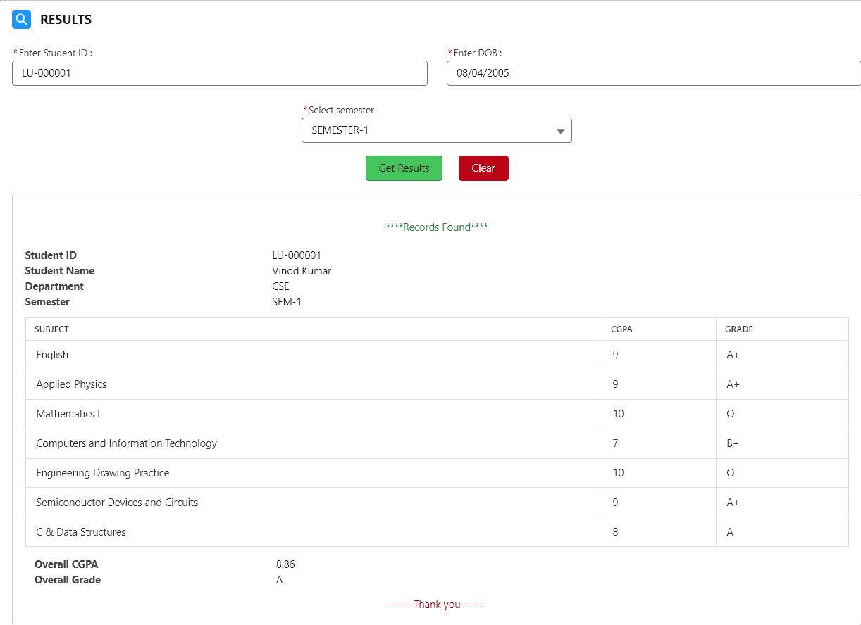

2)Fees Payments check LWC component:

ApexControllerClass

public with sharing class feesPayCheck {

    public feesPayCheck() {

    }

    @AuraEnabled(cacheable=true)

    public static List<Fees_Payment__c> getFeesPayments(String studId){

        Student__c slist = [SELECT Id,Name FROM Student__c WHERE Name=:studId LIMIT 1];

        Id sid = slist.Id;

        List<Fees_Payment__c> feesList = [SELECT Id, Name, CreatedDate, Mode_of_payment__c,Semester__c, Fees_Amount__c,Student_ID__r.Name,Student_ID__r.First_Name__c, Student_ID__r.Last_Name__c,Student_ID__r.Department_ID__r.Name,Student_ID__r.Department_ID__r.Fees_per_Semester__c FROM Fees_Payment__c WHERE Student_ID__c=:sid];

        return feesList;

    }

}

feesCheck.html

<template>

    <lightning-card title="Fees Payments Check" icon-name="utility:money">

        <div class="slds-m-around_medium">

            <div class="slds-grid slds-gutters">

                <div class="slds-col slds-size_1-of-3">

                </div>

                <div class="slds-col slds-size_1-of-3">

                    <lightning-input label="Enter Student ID :" value={sid} onchange={sidChange} required

                        placeholder="LU-XXXXXX"></lightning-input>

                </div>

                <div class="slds-col slds-size_1-of-3">

                </div>

            </div>

        </div>

        <div class="slds-grid slds-gutters">

            <div class="slds-col slds-size_1-of-3">

            </div>

            <div class="slds-col slds-size_1-of-3">

                <button class="slds-button slds-button_success slds-m-right_large" onclick={getPayments}>Check

                    Payments</button>

                <button class="slds-button slds-button_destructive slds-m-left_xx-large" onclick={clear}>Clear

                    All</button>

            </div>

            <div class="slds-col slds-size_1-of-3">

            </div>

        </div>

        <template lwc:if={disp}>

            <div class="slds-box slds-m-around_medium"

                style="font-family: 'Segoe UI', Tahoma, Geneva, Verdana, sans-serif;">

                <div class="slds-align_absolute-center slds-m-top_medium slds-m-bottom_medium">

                    <span class="slds-text-color_success ">****Records Found****</span>

                </div>

                <div>

                    <dl class="slds-list_horizontal slds-wrap">

                        <dt class="slds-item_label slds-text-color_weak slds-truncate" title="First Label">Student ID

                        </dt>

                        <dd class="slds-item_detail slds-truncate" title="Description for first label">{studentId}</dd>

                        <dt class="slds-item_label slds-text-color_weak slds-truncate" title="Second Label">Student Name

                        </dt>

                        <dd class="slds-item_detail slds-truncate" title="Description for second label">{studentName}

                        </dd>

                        <dt class="slds-item_label slds-text-color_weak slds-truncate" title="Second Label">Department

                        </dt>

                        <dd class="slds-item_detail slds-truncate" title="Description for second label">{studDept}</dd>

                        <!-- <dt class="slds-item_label slds-text-color_weak slds-truncate" title="Second Label">Semester

                        </dt>

                        <dd class="slds-item_detail slds-truncate" title="Description for second label">{semVal}</dd> -->

                    </dl>

                </div>

                <table>

                    <thead>

                        <tr>

                            <th>Payment ID</th>

                            <th>Semester</th>

                            <th>Fees Paid</th>

                            <th>Payment Mode</th>

                            <th>Paid Date</th>

                        </tr>

                    </thead>

                    <tbody>

                        <template for:each={paymentRes} for:item="md">

                            <tr key={md.Id}>

                                <td>{md.Name}</td>

                                <td>{md.Semester__c}</td>

                                <td>{md.Fees_Amount__c}</td>

                                <td>{md.Mode_of_payment__c}</td>

                                <td>{md.CreatedDate}</td>

                            </tr>

                        </template>

                    </tbody>

                </table>

                <div>

                    <dl class="slds-list_horizontal slds-wrap slds-m-around_small">

                        <dt class="slds-item_label slds-text-color_weak slds-truncate" title="First Label">

                            Total Course Fees</dt>

                        <dd class="slds-item_detail slds-truncate" title="Description for first label">{totalFees}

                        </dd>

                        <dt class="slds-item_label slds-text-color_weak slds-truncate" title="Second Label">

                            Amount Paid</dt>

                        <dd class="slds-item_detail slds-truncate" title="Description for second label">

                            {feesPaid}</dd>

                        <dt class="slds-item_label slds-text-color_weak slds-truncate" title="Second Label">

                            Due Amount</dt>

                        <dd class="slds-item_detail slds-truncate" title="Description for second label">{feesDue}</dd>

                    </dl>

                </div>

                <div class="slds-text-align_center slds-text-color_destructive">------Thank you------</div>

            </div>

        </template>

        <template lwc:if={errorDisp}>

            <div class="slds-box slds-m-around_medium"

                style="font-family: 'Segoe UI', Tahoma, Geneva, Verdana, sans-serif;">

                <div>

                    <div>

                        <div>

                            <p class="slds-text-color_error slds-text-align_center slds-m-around_medium">!!!!No Data

                                Found!!!!</p>

                            <p class="slds-text-color_error slds-text-align_center slds-text-heading_large">Based on

                                details you entered no data avaliable. Please provide with correct details.</p>

                        </div>

                    </div>

                </div>

            </div>

        </template>

        <template lwc:if={errorDetails}>

            <div class="slds-box slds-m-around_medium"

                style="font-family: 'Segoe UI', Tahoma, Geneva, Verdana, sans-serif;">

                <div class="errorMsg">

                    <div class="slds-align_absolute-center">

                        <p class="slds-text-color_error">Provide all necessary data.</p>

                    </div>

                </div>

            </div>

        </template>

    </lightning-card>

</template>

feesCheck.js

import { LightningElement, track } from 'lwc';

import getFeesPayments from '@salesforce/apex/feesPayCheck.getFeesPayments';

export default class FeePayCheck extends LightningElement {

    @track sid='';

    @track paymentRes;

    @track studentId;

    @track studentName;

    @track studDept;

    @track disp=false;

    @track errorDisp=false;

    @track errorDetails=false;

    @track feesPaid;

    @track feesDue;

    @track totalFees;

    sidChange(event){

        this.sid = event.target.value;

    }

    getPayments(){

        //alert('Started'+this.sid)

        if(!(this.sid==='')){

            //alert(this.sid);

            getFeesPayments({studId : this.sid}).then((result)=>{

                if(result.length>0){

                    //alert('inside res');

                    this.disp=true;

                    this.errorDetails = false;

                    this.errorDisp=false;

                    this.paymentRes=result;

                    this.studentId=result[0].Student_ID__r.Name;

                    this.studentName=result[0].Student_ID__r.First_Name__c + ' ' + result[0].Student_ID__r.Last_Name__c;

                    this.studDept=result[0].Student_ID__r.Department_ID__r.Name;

                    //console.log(result);

                    this.totalFees = (result[0].Fees_Amount__c)*8;

                    this.calcualateFeesPaid();

                    this.feesDue = this.totalFees - this.feesPaid;

                    //console.log(this.totalFees);

                    //console.log(this.feesPaid);

                    //console.log(this.feesDue);

                }else{

                    //alert('inside empyt field');

                    this.errorDetails = false;

                    this.disp=false;

                    this.errorDisp=true;

                }

            }).catch((error)=>{

                //alert('inside error start');

                this.errorDetails = false;

                this.disp=false;

                this.errorDisp=true;

                //console.log(error);

                //alert('inside error end');

            });

        }else{

            this.disp=false;

            this.errorDisp=false;

            this.errorDetails = true;

        }

    }

    calcualateFeesPaid(){

        this.feesPaid = this.paymentRes.reduce((total,res)=> total+res.Fees_Amount__c,0);

    }

    clear(){

        this.sid='';

        this.disp=false;

        this.errorDisp=false;

        this.errorDetails=false;

    }

}

feesCheck.css

table {

    background: #FFFFFF;

    border-radius: 0.25em;

    border-collapse: collapse;

    margin: 10px 0px;

}

th {

    border-bottom: 1px solid #DDDDDD;

    color: #333333;

    font-size: 0.85em;

    font-weight: 600;

    padding: 0.5em 1em;

    text-align: left;

    border: 1px solid #DDDDDD; /* Add this line */

}

td {

    color: #333333;

    font-weight: 400;

    padding: 0.65em 1em;

    border: 1px solid #DDDDDD; /* Add this line */

}

.disabled td {

    color: #999999;

}

tbody tr {

    transition: background 0.25s ease;

}

tbody tr:hover {

    background: #F5F5F5;

}

Note: Use above components in experience builder and adjust the permissions such that students(guest users) are able to check their results and fees payment.



THE END

